
Pathways to Nature KA2 Project
Improving Youth Mental Health and Wellbeing through Connecting Young People with Nature using Youth Work Methodologies
Training Resource for Youth Leaders
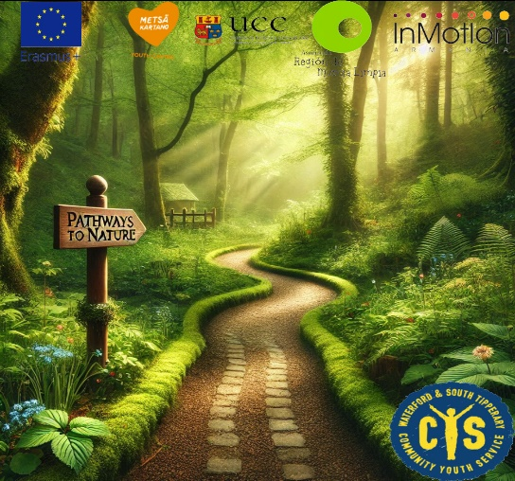
Contents page:
Page 3 - What is the ‘Pathways to Nature’ Project?
Page 4 - Purpose of this Training Resource
Page 5 - How to use this Training Resource
Page 6 - Getting started….
Page 7 - Key Sections of the Training Process
- What is Youth Work, and what are the 7 Youth Work Outcomes? (Page 7)
- Relationships (Page 11)
- Values (Page 13)
- Supporting the ‘Inner Child’ (Page 15)
- The 5 Pathways to Nature (Page 17)
- Measurement (Page 22)
- Evaluation (Page 24)
- Design Thinking (Page 26)
- The Nature Based Initiatives, Dragon’s Den and ‘Golden Tickets’ (Page 28)
- Project Management (Page 32)

What is the Pathways to Nature Project?
The ‘Pathways to Nature’ Erasmus+ Project is a Cooperation Partnership Project (Key Action 2) between 5 Organisations from across Europe. The aim of the Project is to improve youth mental health and wellbeing through connecting young people with nature using Youth Work methodologies.
Young people across Europe have been telling Organisations for a number of years now that there are very real mental health struggles impacting on their lives, so the Project partners decided to work with young people to see what could be done.
It started very simply with the fact that in general young people feel better when they’re out in nature. It seems to be widely acknowledged, but if so, why don’t we just do it and then feel better? If it was that easy though, all the problems would be solved - but as with many deceptively simple answers, the reality is more nuanced.
Together with young people, Youth Workers and academics created a 2-year Project that would involve young people from each of the 4 countries involved (Ireland, Spain, Finland and Armenia) attending an innovative, co-designed Pathways to Nature Training Course built around the 5 Pathways to Nature – senses, emotions, beauty, meaning and compassion.
The young people would then design their own Nature Based Initiatives and implement them over the course of a year together with other young people and their own local communities. The Partners Organisations are measuring the impact of the Project on Youth mental health and wellbeing, and the young people will present the results at a series of Youth Conferences to be held across Europe in late 2025.
The Project is running between January 2024 and December 2025, and is supported by Ireland’s National Agency for Erasmus+, Léargas.
The Partner Organisations are:
- Waterford and south Tipperary Community Youth Service, (Waterford, Ireland)
- University College Cork, (Cork, Ireland)
- Metsakartano National Youth Centre (Rautavaara, Finland)
- Asociacion Region de Murcia Limpia (Murcia, Spain)
- InMotion Armenia (Yerevan, Armenia)

Purpose of this Training Resource:
- This Training Resource is a guide to support you to create and develop an appropriate response to the needs of young people, and to assist and support safe practice designing a Pathways to Nature Training Course.

- To provide advice, guidelines and templates for Staff, Volunteers and other Leaders when planning Pathways to Nature Training Courses.

- To be used as a resource to develop a Training Course for Youth Workers or for young people. This is not an absolutely set-in stone-prescriptive Training Programme; instead it is designed to equip a Youth Worker to ‘dance in the moment’ with a group.

- To make this Training Resource as accessible, inclusive and user-friendly as possible, so that it will be used in the real world by real people doing real work with young people.

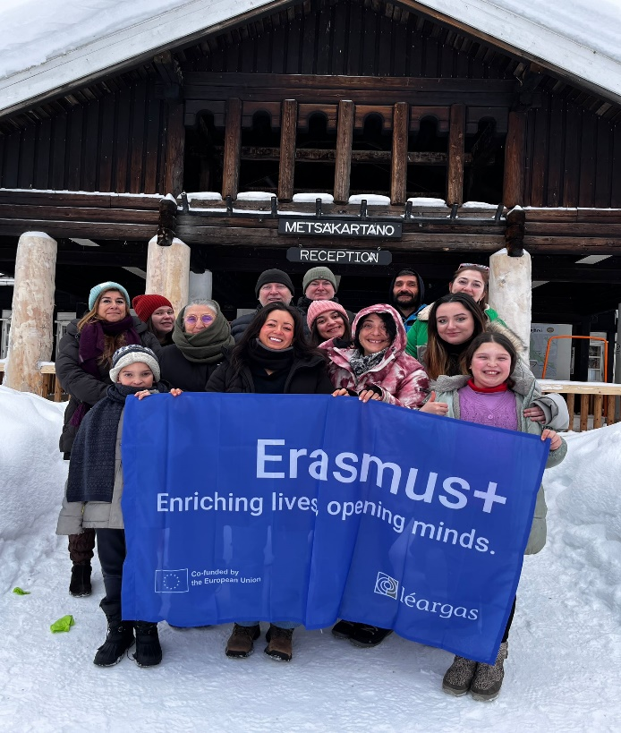
Youth Workers and Young People at Metsakartano Youth Centre, Finland learning about Pathways to Nature in -28 degrees!

How to use this Training Resource:
Youth Work is by its nature, inherently flexible and adaptable, and what works with one group of young people may fall flat with another. Therefore, the skill of the Youth Worker/Trainer is absolutely vital in the delivery of any Youth Work Training Programme, and this Resource aims to upskill the practitioner to develop their own appropriate response for their group. The ideas and the process are the same for every Training Programme, but the application is in the hands and the skills of the Trainer.
We’ve included a number of sample sessions in this Resource that the Team used to run the Programme in Ireland in March, 2023, but feel free to change and adapt, depending on the needs and starting points of your participants.
The overarching framework is to:
- Connect - Relationship development and bringing everyone together
- Engage – Develop the vision, and learn the knowledge, skills and attitude to deliver that vision
- Empower – Hand the power over to the participants and support them over the long term to achieve their aims
There are different sections which should be delivered in the same order:
1st – Introductions, Group Agreements, Youth Work, Relationship Building and Communicating with each other, Identifying Shared Values, Reflective Practice
2nd – Experiential learning around the 5 Pathways to Nature:
- Senses
- Emotions
- Beauty
- Meaning
- Compassion
3rd – Youth Work
4th – Design Thinking
5th – Measurement, Evaluation, Reflection
6th – Project Management Skills, Nature Based Initiatives
7th – ‘Dragon’s Den’ and ‘Golden Tickets’ (Innovation Vouchers)

Getting Started:
There are a couple of things that you need to think about before getting started:
Impact –
What is the change that you’re trying to create? What do you actually want to see happen? It’s really important to start with the end in mind. Unless you and your group understand very clearly what you’re trying to do, the Project can deteriorate very quickly if you’re not all aligned and agreed on what you’re trying to do.
The Pathways to Nature Project Management Team spent a long time coming up with a 1-sentence answer to what impact we wanted to create – ‘to improve youth mental health and wellbeing through connecting young people with nature using Youth Work methodologies’.
Participants –
As Youth Workers, we’re very interested in working with young people who have fewer opportunities, but that doesn’t mean that this Programme is solely designed for that group. Almost everyone can benefit from a well-designed Programme built around nature connection, wellbeing, creativity and fun.
Developmental Group Work
This is fundamental to the work that we do with young people in the Project, and it’s important to understand the process of working with groups, so that environments can be created where people can share in a common life, form beneficial relationships and help each other.
The work is rights-based, and young person-centred, building on the strengths of young people while being flexible and attentive to their needs, and encourages a sense of belonging and ownership.
The work is developmental and empowering with a view to encouraging young people to reach their full potential. The work emphasises relationship building, listening, trust, acceptance, patience, and respect.
Entering groups or forming them, and then working with them so that members are able to be around each other, take responsibility and work together on shared tasks, involves some very sophisticated abilities on the part of practitioners.

Key Sections of the Training Process:
- What is Youth Work and What are the 7 Youth Work Outcomes?
- Aim of the Session
To ensure that participants know what Youth Work is, and that there is a common understanding among participants. We have found that the concept and practice of Youth Work varies widely across Europe, and there needs to be a common understanding.
To understand that Youth Work outcomes include the following 7 Proximal Outcomes of Youth Work (as they are known in Ireland):
- Communication Skills
- Confidence and Agency
- Planning and Problem solving
- Relationships
- Creativity and Imagination
- Resilience and Determination
- Emotional intelligence

- Key Messages
- Youth Work is ‘planned, informal education’
- Developmental Group Work is the key methodology
- Relationships, relationships, relationships
- Voluntary participation
- Start where the young person is at
- Experiential learning
- Outcome focused
- Long term work

- Sample Exercises
The following is an example of a 3-hour session on Youth Work
Pathways to Nature Training Session
“The Nature of Youth Work”
Session Plan

10:30 - 10:50 Welcome and Opening Round

- Share your name, where you are from and 1 thing you have enjoyed about Pathways to Nature so far

10:50 - 11:15 “When I Was Young”: Individual Reflective Exercise

- Each participant traces one of their hands
- Reflecting on when they were young, the invitation is to write into each finger one thing that connects them with their memory/experience of being a young person;

Something I needed (Need)
Something I was interested in (Interest)
Something I struggled with (Struggle/Concern)
Something/someone that influenced me (Influence)
Something I wanted to achieve/aim for (Goal)

The completed hands will then be stuck up to form the layered petals of a flower; symbolising youth as a time of growth and change, reflecting on how our journey of growing (up) is shaped by our experiences, relationships, personalities, opportunities, environment. Leading into the next exercise – How does our work (Youth Work) contribute to/shape young people’s lives?

11:15 – 12:00 Putting the Pieces Together – Our Picture of Youth Work

A Picture paints a Thousand Words – art is a universal language

Individuals will be arranged into 4 Groups (mix of nationalities in each) with the following Task;

- A large pre-prepared jigsaw puzzle piece will be given to the group
- Using whatever art supplies they choose, the group must show us on the page what Youth Work is (pictures, symbols, colours, textures)
- Each person can take their own little corner or the group can work together to create a collective picture – whatever way they do it, they must share with each other what their contribution means
- 1 person will be asked to say a few words about their piece as the Jigsaw is assembled
- The whole group will be invited to stand back from the piece and take a moment to look at it
- What stands out? What do you notice? Common themes?

12 – 12:15 Comfort Break

12:15 – 1:00 Youth Work Works! – Our Tree of Knowledge

- Break the group up into 3 or 4 small groups– different combination from before
- Each group will be asked to consider a different aspect of Youth Work;

Roots – Underpinning principles/values/frameworks for our work – written onto cards
Trunk – Methodologies/Approaches – what we do and how we do it – written on a white sheet with fabric pens
Branches – outcomes and social impact – the difference the work makes for young people and wider society – written on individual paper leaves with string loops for hanging them

With a real tree as our focal point, we put together our Tree of Knowledge – cards placed around the Roots, sheet content shared and then wrapped and secured around the Trunk and leaves hung on the Branches; recognising, validating and sharing what we know; making visible our practice wisdom and drawing out what the tree can tell us about young people/youth work;

Strong roots; independent yet interconnected and interdependent; resilient; adaptable; contributing to community; unique and beautiful; vulnerable to changing environment yet survivors; diversity; universality; living and breathing; fundamental to our human future

1:00 – 1:15 Thirteen in 13

Facilitator verbal input on 13 key concepts that inform WSTCYS’ Youth Work practice (max 1 minute on each ) – linking it with everything people have already identified, shared and created today

1:15 – 1:30 Closing Round

- Seated around the tree, each person is asked to share one thing they are taking away from the session

- Useful Further Reading
- Leslie Button, Developmental Group Work with Adolescents (1974)
- Mark Smith, Creators not Consumers (1982)
- DCEDIY, Government of Ireland, Opportunities for Youth (2024)
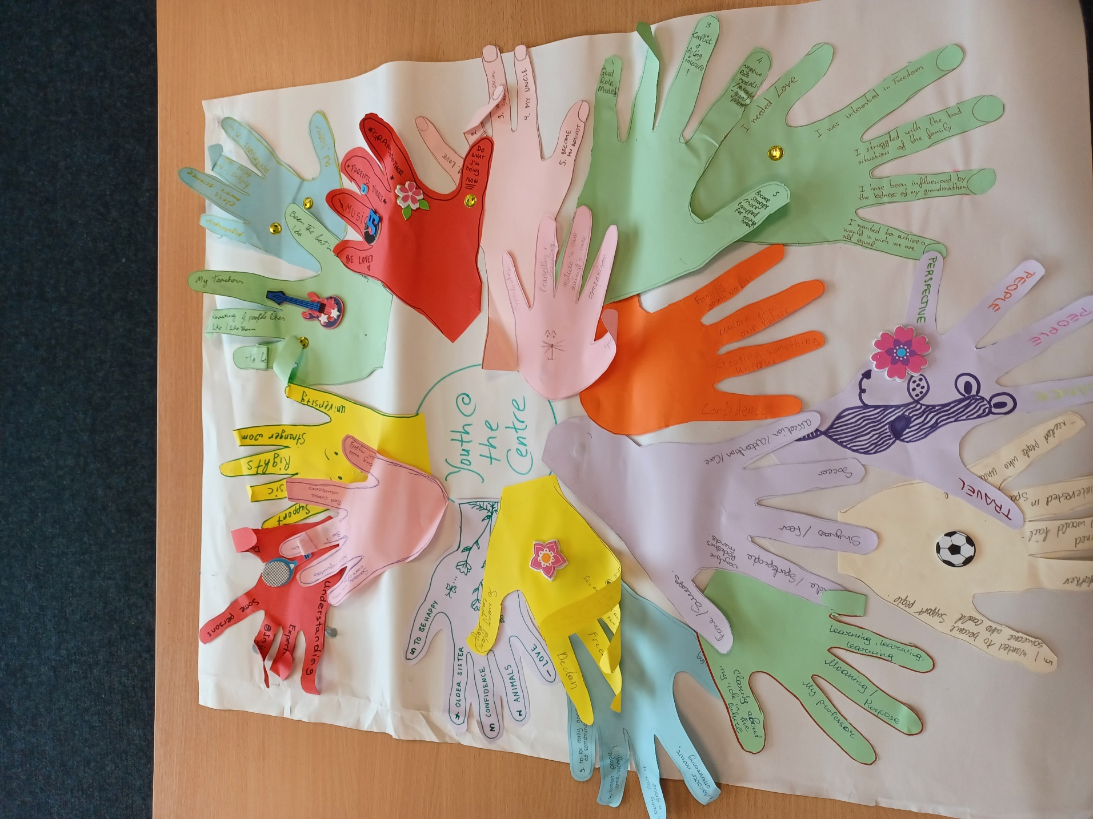
What is Youth Work?

- Relationships
- Aim of the Session(s)
Getting to know each other and developing relationships is very much a process that takes place over time, and involves incremental growth and slow trust-building. However, I have never known anyone to say that they spent too much time on building relationships!
What can be done though, is that the Trainers can put in place structures and spaces that allow relationship to take place, and encourage people to trust and be open with each other.
- Key Messages:
- Checking in and checking out before and after groups is just a part of the way we do things, practicing openness, listening skills and empathy
- Group Agreements as to how we’ll all work together are very important
- Fun, and the ability to laugh with each other, is essential
- Numerous ice-breakers work really well
- Sample Exercises:
There are hundreds of examples of ice-breakers available, and many practitioners will have their own favourites, but we have a few of our own favourites listed here:

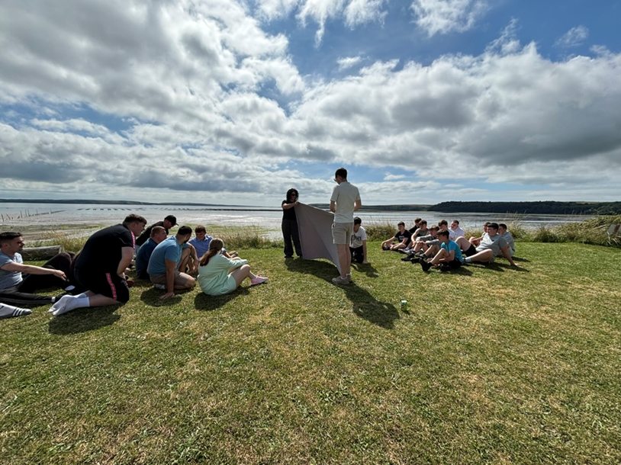
Using a blanket ice-breaker game while getting to know each other in Ireland
Zip/Zap/Boing - Concentration & Eye Contact

Standing in a circle, one participant begins with the word “zip” sending the word with a clap to the person next to him/her. 1st round only with that word to try. The clap and the word at the same time, with energy.
The word “boing” is rebound, the action comes back to the person who has sent it. Also it can be used to change direction.
“Zap” must be sent to someone that is not close to you, having eye contact first.
At the beginning you can go slow, but when you've tried some rounds I recommend to keep the rhythm.
Next step could be a kind of “nice punishment” for those who make a mistake, like singing or dancing, something short and funny.

Follow the numbers - Concentration & Physical/ Vocal activation

Participants can be in a circle or around the room. They have to follow the instructions linked with the numbers, when the facilitator says: 1- They jump 2- They clap 3- They talk loud ‘Pumpkin face’ (opening arms and legs) 4- They say ‘Tiny Little Prune’ (closing their bodies in the action). After some rounds, the facilitator can make variations, swapping 1 for 2, or 3 for 4 to keep the concentration.

Tennis Balls - Concentration & Teamwork

Participants make a circle. First round they have one tennis ball to pass between them, throwing the ball “nice”, with eye contact. Objective should be to keep the ball moving. Second round they say their own name when they pass the ball, repeat the name when they receive it before throwing back the ball.
When they feel comfortable with that, the facilitator can add a second tennis ball to keep concentration and ask for other tasks (days of the week, months of the year…).

Warm up the body - Physical Activation

Rediscovering anatomy, opening physical abilities no matter to the level of previous movement experience. Move and stretch every part of your body, individually. We begin slowly, saying Yes and No with the head, then continue with shoulders, arms, hands, chest, hips, legs, knees and toes. No pressure or pain. At the end we shake different parts of the body connecting with the sound of our voice.

- Useful Further Reading
- ‘The Glue that Holds Our Work Together’ by Helen Rodd & Heather Stewart (2009, Youth Studies Australia)
- Building Relationships through Effective Interpersonal Engagement: A Training Model for Youth Workers Pat Henry, Susan Morgan and Mark Hammond (2010, Youth Work Ireland)
- Values
- Aim of the Session
- To put shared values at the centre of the project. Core values are individual concepts that support the Project’s vision for the future. Understanding the group’s values can help to create a vision for the future where we all thrive.
- To enable both an individual and group process of reflection around what’s really important in life and in the Project
- Key Messages
- That living in a way that’s in accordance with our values leads to a life worth living
- That people are very similar no matter where they’re from, that most people want a good life and to make a difference in their world

- Sample Exercises
Values Questions

- What are the 3 most important values to you in this Project?

- Why are you taking part in this Project?

- What can you give to the Project?

- What is important to you to get from this Project?

What are our Values?

The following is the philosophy of Charles Schulz, the creator of the 'Peanuts' comic strip.
- Name the ten wealthiest people in the world.
- Name the last five European Cup trophy winners.
- Name the last five winners of the Miss Ireland beauty pageant.
- Name ten people who have won the Nobel Prize for Physics.
- Name the last half dozen Academy Award winners for best actor and actress.

How did you do?
The point is, none of us remember the headliners of yesterday.
These are no second-rate achievers.
They are the best in their fields.
But the applause dies.
Awards tarnish ...
Achievements are forgotten.
Accolades and certificates are buried with their owners.
Here's another quiz. See how you do on this one:
- List a few teachers who aided your journey through school.
- Name three friends who have helped you through a difficult time.
- Name five people who have taught you something worthwhile.
- Think of a few people who have made you feel appreciated and special.
- Think of five people you enjoy spending time with.
Easier?
The lesson:
The people who make a difference in your life are not the ones with the most credentials, the most money ... or the most awards. They simply are the ones who care the most.

- Useful Further Reading
- Start with Why, Simon Sinek (2009)
- Rooted in Decency, Colleen Doyle Bryant (2022)
- The Little Book of Values, Julie Duckworth and Ian Gilbert (2009)

- Supporting the ‘Inner Child’
- Aim of the Session
- To put play, fun, creativity and imagination at the centre of the Project
- To ensure that creativity is recognized as a powerful force and as an outcome in Youth Work. Creativity is related to resilience and wellbeing, and can have a powerful effect on self-esteem and overall confidence.

- Key Messages
- Being creative and using the imagination to think of the future is very powerful, unlocking ideas and inspiring vision
- It’s so much easier and more enjoyable to be pulled along by an inspiring vision than it is to pushed and forced to move under duress
- For this Project, the Inner Child refers to the part of us that's carefree, innocent, loving, and playful,

- Sample Exercises
Sculptures: Images with the body. To work with somebody else's body.

Participants make three lines. Models / Sculptors / Statues
The line “Models” make an image using the body (gesture, emotion). The line “Sculptors” have to see the image and they have to reproduce the image that they
have seen in the line “Statues”. Then swap around the lines.

Fixed Images:

By groups of 4/5 they have to create a fixed image with any topic that facilitator gives them (ex:
topic about “NATURE”) 1st they talk about what they want to represent, 2nd in silent they
show their image to the big group.
(First baby step of Image Theatre from Theatre of the Oppressed by Augusto Boal)

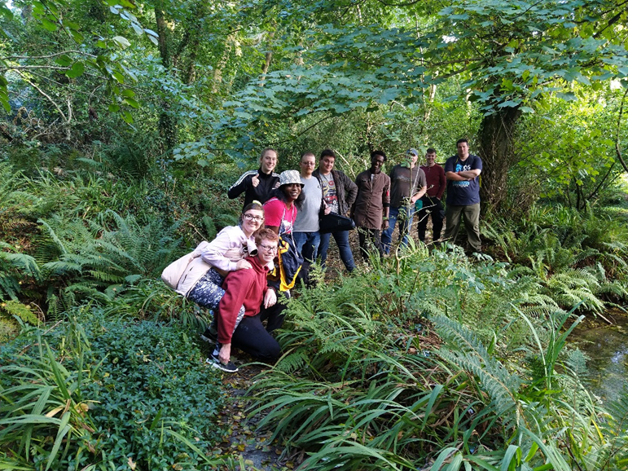
Young people on a Pathway to Nature, exploring in Spain

- Useful Further Reading

- ‘Why is Creativity Important and What does it Contribute?’, National Youth Council of Ireland (https://www.youth.ie/articles/why-is-creativity-important-and-what-does-it-contribute/)
- Unleashing Young People’s Creativity and Innovation, European Commission, (https://ec.europa.eu/assets/eac/youth/library/publications/creativity-innovation_en.pdf)

- The 5 Pathways to Nature
- Aim of the Session(s)
- To make sure that young people understand that there are many different ways to be in nature and to work with nature as a partners
- The 5 key Pathways to Nature that we are use in this Project are:
Senses / Emotions / Beauty / meaning / Compassion
To give participants the opportunity to experience these 5 Pathways to Nature through active, experiential learning followed by reflection

- Key Messages
- That everyone feels better when they’re working in harmony with nature
- That nature is everywhere, and that it includes humans

- Sample Exercises
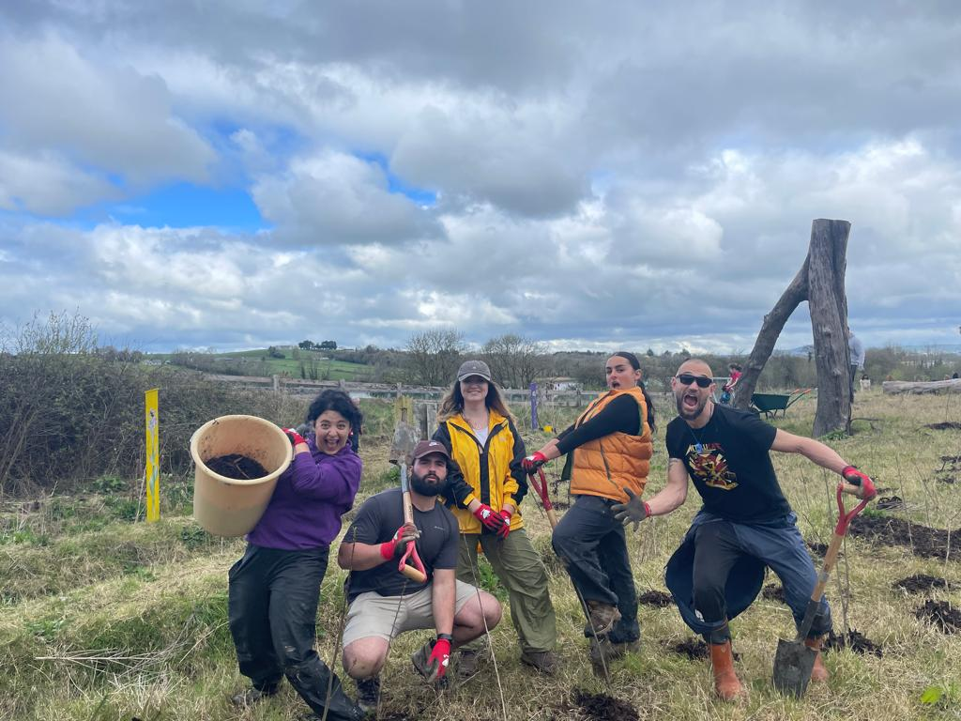
Spanish Youth Leader Team demonstrating their compassion for nature
through planting trees

Tree Hugging Championship

Objective: low impact fun activity to promote nature connection

Nature Pathways:
Senses ***
Emotions ***
Beauty *
Meaning *
Compassion **

Preparation:
A suitable forest or park and permission of land owner.
Completion of a Hazard Identification & Risk Assessments addressing any mitigating actions, carried out by a competent person.
Participants: individuals or teams; timekeeper; & jury

Method:
Speed hugging: Most trees hugged in one minute.
In a clearly marked area, hugging as many different trees as possible in one minute.
Hugs should be with chest and both arms & hands in contact with the tree.
Participants ranked by: Individual total or Team total
Particular considerations:
One-person timing and one judge per participant, if participants are competing simultaneously.
Trees should be without branches up to above head height.
The area should also be free of slip & trip hazards.

Creative hugging: Most creative hug.
Style open to contestant’s own interpretation, one tree only, lasting maximum one minute.

Five minutes of preparation and practice.
Either individual or team.
Participants ranked on: creativity, awareness of the tree and surroundings,
Particular considerations:
Participants should present their hug to judges first for marking and once all participants are marked then may repeat their hug for all participants.

Dedicated hugging: Hugging a tree that looks like it needs a hug.
Most dedicated hug, showing presence, intention, love and respect of a specific tree of the contestant’s choice, lasting maximum one minute.
Particular considerations:
Participants should present their hug to judges first for marking and once all participants are marked then may repeat their hug for all participants.

The experience could be extended by adding the Forest of Human Trees Activity.

Total Time: About 2 hours for 15-20 people

Night Walk on the Forest Path

Objective: Facilitate solitude in nature in a safe way.

Nature Pathways:
Senses **
Emotions ***
Beauty *
Meaning ***
Compassion *

Preparation
A suitable forest at night, with accessible paths and permission of land owner.
Completion of a Hazard Identification & Risk Assessments addressing any mitigating actions carried out by a competent person.
At least two group leaders familiar with the forest and activity.

Method:
On arrival, the group gathers in a circle and is invited to reflect on how trees and forests are viewed by people.
Discussion points may arise around: biodiversity, climate change mitigation, ecosystem services, wood and non-wood forest products, recreation, heritage, mythology.
The group is then asked to consider how night-time changes the human relationship with forests. Individuals may share stories and anecdotes in particular in art and mythology.
The group is issued with small wax or electric tea lights and a lit tea light is placed at the gathering circle.
The group is invited to walk together along a forest path. Torches may be used to clearly illuminate the forest path and surroundings for everyone’s comfort.
Participants are asked to consider placing their lit tea light at intervals along the path, within sight of at least one previous tea light. Participants are also asked to consider the distance interval between tea lights that they may be comfortable with, and also their companions may be comfortable with.
The walk continues until all the lit tea lights are placed.
The group reforms a circle within sight of the final lit tea light and all torches are switched off so the group is in darkness, apart from any lit tea light within sight along the path.
The group is invited to be silent and reflect on their senses as they become adjusted to the dark, for some minutes. Sights, sounds and smells may be explored.
Participants are invited to walk back along the path alone, in darkness and solitude. Those that do not wish to walk alone could pair up or be paired with a group leader.
A group leader should be the first to walk back and participants should depart at intervals of about 1-2 minutes.
Participants should walk slowly, conscious of maintaining separation between the person in front and behind. If a participant becomes uncomfortable they should wait at a lit tea light and join the next participant.
A group leader should be the last person to walk back and should pick up each tea light when passing.
As participants return to the starting circle, they should remain quiet until all participants return.
Gathering around the circle, participants are invited to reflect on the experience.
The experience could be extended as follows:
Prior to the night walk, participants are issued with pen & paper and invited to consider an existing or new piece or art, poem, song lyric or quotation related to drawing meaning from nature and put this on paper. These are presented now as small scrolls and distributed anonymously to the participants.
Participants are given time to read and reflect on their scroll and share with the group.

Total Time: 1 – 2 hours, depending on group size.

SENSES:
Sensory contact with Nature.
Exploring and experiencing nature through all the senses. Notice and actively engage with nature, spending time fully experiencing nature with all your senses.
(Exploration promotes curiosity and discovery while limiting the fear of failure.)
“They smell the air, feel the grass, taste the rain, see the sky, and hear the blowing wind.”
Examples: Sit and listen to the birdsong. Smell wildflowers. Watch the breeze move the trees. Go barefoot. Taste the fruits of nature.
Activity:
1st Exploring the possibilities of their senses in nature, individually, as kids with curiosity.
Start getting touchy-feely more and pay close attention to what you’re touching. Look at it, focus on it, and think about what it feels like.
2nd Sharing (by actions and not only by words) what they've discovered (it can be by pairs or small groups).
3rd COLLECTIVE CREATION:
Participants are divided in three groups, 1st group focus on the senses of Taste and Smell, 2nd group focus on the sense of Touch and 3rd group focus on the sense of Hearing (it's up to them to use the sense of sight or not). They brainstorm to prepare an immersive experience using senses for the other participants. Preparation, rehearsal and performance.
*Some notes:
The human body has five main sense organs- eyes, which provide the sense of sight; nose, which provides the sense of smell; ear, which provides the sense of hearing; skin, which provides the sense of touch; and tongue, which provides the sense of taste.
Simple exercises such as cardio, yoga, and aerobics can improve smell. This is likely because increased blood flow can clear nasal passages. Our hearing sensation can also be improved through exercise. This is also probably due to increased blood circulation which strengthens nerve functions which allows our auditory cortex to process sound better.

EMOTIONS:
Noticing and welcoming the feelings that nature inspires.
As we seek the wilderness, and untangle our own emotions.
This pathway is about feeling alive through the emotions that nature brings.
Engage emotionally with nature by finding joy in wildlife, find happiness and wonder in nature, embrace Nature in times of sorrow by reflecting on and sharing your feelings about nature with others.
The simple difference between emotions and feelings is that emotions are physical reactions that occur in response to stimuli, while feelings are the mental associations and interpretations of those emotions.
The concept of five universal emotions is often attributed to psychologist Paul Ekman's research. These emotions are considered universal because they are recognized and expressed similarly across different cultures and societies.

1.Happiness: This emotion is associated with feelings of joy, contentment, and satisfaction. It's often expressed through smiling, laughter, and positive body language.
2.Sadness: Sadness involves feelings of sorrow, grief, and disappointment. It's typically expressed through expressions like frowns, tears, and slumped posture.
3.Fear: Fear is a response to perceived threats or danger. It triggers the body's fight-or-flight response and is expressed through wide eyes, raised eyebrows, and a tense posture.
4. Anger: Anger arises in response to perceived injustices, frustrations, or threats. It's expressed through clenched fists, narrowed eyes, raised voice, and aggressive body language.
5. Surprise: Surprise occurs when something unexpected happens. It's often expressed through widened eyes, raised eyebrows, and an open mouth.

These five emotions are believed to be fundamental to human experience and are thought to have evolved to help humans navigate their environment and interact with others effectively.

Together as a team counting* - Concentration & Trust

Participants make a circle. They have to count from 1 to 20 without strategy. Everybody has to say at least one number. If two people say one number at the same time they have to start from the beginning. They can't order or make a plan about how to do it. The focus must be on concentration, listening to each other, working in silence and feeling the group atmosphere. 2Nd round with eyes closed.
(Variations: Facilitator asks them to jump or clap at the same time, all together, without talking or giving signals. The next step is to jump/clap at the same time with the eyes closed).

"Emotion Stations."

1. Before the activity, prepare five stations, each representing one of the universal emotions (happiness, sadness, fear, anger, surprise). At each station, place visual cues or prompts that evoke the corresponding emotion. (Emoji’s, colours, materials)
2. Gather the group of youth workers and explain that their goal is to visit each station and identify the emotion represented there.
3. Exploration: Divide the group into smaller teams or INDIVIDUALLY and Encourage them to explore the outdoor space and visit each station.
4. At each station, encourage the participants to discuss and share their interpretations of the emotion represented there or write their thoughts. They can talk about what they see, how it makes them feel, and any personal experiences they associate with that emotion connected with Nature.
5. Reflection session:
- What emotions did you find most easily? Which ones were more challenging?
- How did being outdoors affect your perception of the emotions?
- Did any of the stations surprise you? Why?
- How can understanding these emotions help us in our work with youth?

“Forest of Human Trees”

1st Take a comfortable space to stand for some time and close your eyes. Breathe deeply.
2nd You begin to think about yourself as a tree. How is that tree? Young and green? Old with
roots very deep in the ground? How are the branches? Feel your arms as branches, you can
move them too.
3rd I will touch some trees on the shoulder and they will become humans. They can walk
around that forest and observe it.
4th The humans turn trees again and swap around.
5th Say goodbye to your tree

- Useful Further Reading
- The Nature Connection Handbook, by the Nature Connectedness Research Group at the University of Derby (2022)
- The Natural World Around Me; A Qualitative Exploration of Young People’s Environmental Perceptions and Relationship to Nature, by Topaz Shrestha, Dr Zelda Di Blasi, Dr Sarah Foley, Dr Marica Cassarino, Declan O’ Driscoll & Tom Kent (2023)

- Measurement
- Aim of the Session
- To ensure that the improvements in Mental Health and Wellbeing are measured, and that Youth Workers and participants know how the process works
- To make sure that these are measured using the Wellbeing Scale, which is a verified tool across in each country where the Project is taking place
- Key Messages
- It’s vitally important to measure the outcomes and impact of the Project, because we need to build an evidence base that shows that the Project works
- Two measurements using the Qualtrics Tool are taken with all the young participants over the life of the Project – one at the start, and the second once 70% of their Nature Based Initiatives are completed.
- In addition, Focus Groups will be run in each country focusing on the qualitative aspects of the Project and its impact on the mental health and wellbeing of participants
- Sample Exercises
- The tool has been put online for ease of use and also translated into each language so that it’s accessible by all participants – it can be accessed using the QR Code below

ucc.qualtrics.com

The following are the instructions to work with young people using the Wellbeing Index
Why?
To explore young people's sense of wellbeing before and after the Pathways to Nature Project
How?
1. Make sure all young people have a phone/laptop to answer the survey on
2. Let the young people know they will answer a short survey – “it is not a test and we are just interested in your opinions”
3. Let the young people know the survey is completely anonymous and confidential and that there is no time limit on answering the questions
4. Scan the QR code or follow the link to access the survey
5. Select your preferred language (English, Spanish, Armenian or Finnish)
6. First, you will be asked a few questions about yourself (e.g. your age, country etc.)
7. Click the arrow and then you will be asked a few questions about your wellbeing
8. Explain to the young people that questions are scored with smiley faces where the red sad face means “not at all happy” and the green smiley face means “very, very happy”

- Useful Further Reading
- Personal Wellbeing Index – School Children, Manual 2023; Robert A. Cummins and Anna L.D. Lau, Deakin University, Melbourne
- Measuring Mental Wellbeing in Children and Young People, Public Health England, 2015
- Evaluation

- Aim of the Session
- Evaluation is not just a session in the Programme – it’s a continuous process of checking whether we have achieved what we want to achieve.
- In that way it can be both formative (taking place at regular intervals in a learning process) and summative (taking place at the end of a process)
- It’s really important to create a culture where people can feel free to give honest feedback, and that goes back to the values that we live out in the Programme

- Key Messages
- Evaluation is the structured interpretation and giving of meaning to predicted or actual impacts of proposals or results. It looks at original objectives, and at what is either predicted or what was accomplished and how it was accomplished.
- Evaluation is a vital part of the learning process. It’s very much about seeing if the process has delivered what it set out to do. In order to learn, we need to evaluate and check that we have learned.

- Sample Exercises
The following are examples of Evaluation questions used with participants in the Training Course:

1. Was the learning environment good for your own learning process:
2. What was your most powerful learning outcome?
3. Which activity provided the best learning for you?
4. How do you evaluate your own contribution?
5. What aspects of this Training are you going to use in your own daily work?
6. What suggestions do you have for the next edition of Pathways to Nature Training Course?
7. Is there anything else that you’d like to add?

- Useful Further Reading
  - ‘Evaluating Outcomes - How to use Capturing the Magic’, Saoirse Reynolds, National Youth Council of Ireland, 2018
  - ‘Youth-Led Research and Evaluation: Tools for Youth, Organizational, and Community Development’, New Directions for Evaluation, no. 98, Summer 2003, Jonathan K. London, Kristen Zimmerman, Nancy Erbstein,

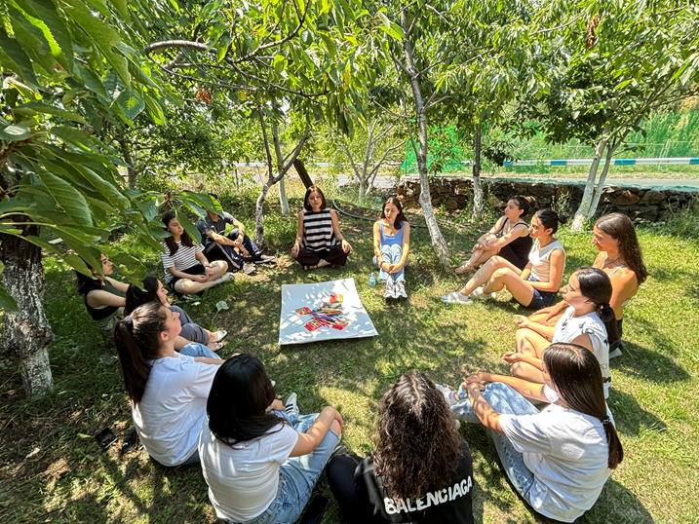
Evaluating in Nature at the Armenian National Training Course

- Design Thinking
- Aim of the Session
- To enable participants to understand and believe that we can make a difference, and that there is a process where we can intentionally get to a place where new relevant ideas exist to make changes in our world
- To give participants an experience at using the key ideas contained within the Design Thinking process
- To stimulate participants to start the process of developing ideas and plans to address challenges that they’ve identified in their localities
- Key Messages
- That there are 4 key principles in the Design-Thinking concept – that it is Human-centered, collaborative, optimistic and experimental
- That there are 5 key sections to the process:
- Empathize
- Define
- Ideate
- Prototype
- Test

- Useful Further Reading
- Design Thinking Toolkit from ‘Design for Change’ (EU Funded Partnership Project)
https://padlet.com/redirect?url=https%3A%2F%2Fsocialchange.how%2F

- Design Thinking for Partnership Projects, Léargas Erasmus+ Training Course, (2023)
https://padlet.com/CSTeam/design-thinking-for-partnership-projects-tu7tc686t4hibywg/wish/MxrmZY3w3YR8aGOq

- Sample Exercises

There are a large number of useful exercises that can bring the idea to life for participants. Examples here are:
- Empathy mapping
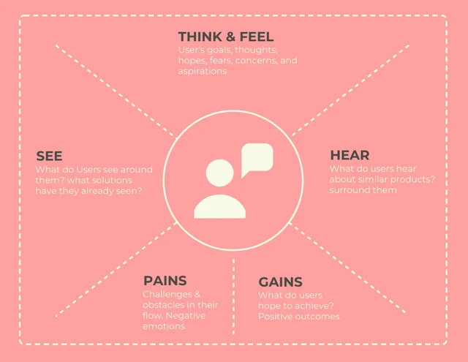
- Ideating through Brainstorming
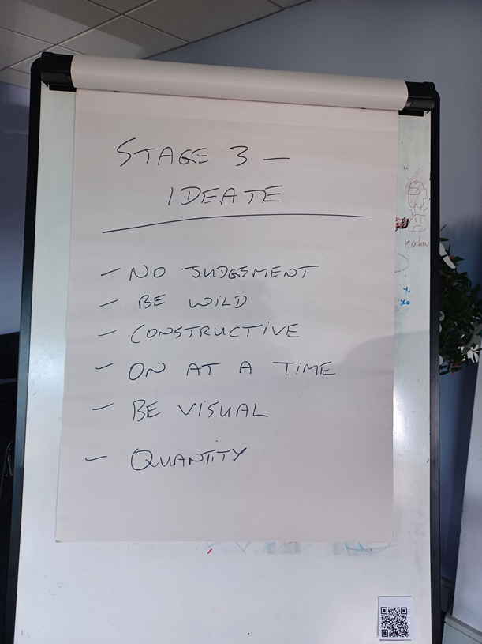

- THE NATURE BASED INITIATIVES, DRAGON’S DEN AND THE ‘GOLDEN TICKETS’
- Aim of the Session
- Towards the end of the Training Course, the focus is very much on empowering participants to go out into their communities and take positive pro-environmental actions that will lead to improvements in their own mental health and wellbeing
- They need to decide on the actions that the Team wants to take, and they need to plan this (with the appropriate support of the Leaders)
- They develop a plan, work on it and present it to a group of ‘experts’ who will analyze, ask questions and finally judge the proposal. This is based on the methods of Dragon’s Den (in Ireland) or Shark Tank (in the US) The experts can be a group of Youth Leaders or Trainers, but it’s very important that the process is respectful, supportive and overwhelmingly positive, rewarding the young people for their creativity and imagination.
- Ultimately the participants are rewarded with ‘Golden Tickets’, like in the films about Willy Wonka (or ‘Innovation Vouchers’) worth a certain amount of real money, depending on the budget of the Training Course. This marks a decisive point in the process that makes the prospect of delivering a plan very real – the barrier around having no money is removed, and the young people have the resources to take action

- Key Messages
  - The key messaging here is that young people are resourceful and creative, that they can develop ideas and plans, and that they can actually achieve tasks and goals that they set themselves. It’s all about empowering young people to have confidence to address the challenges in their lives

- Sample Exercises
Examples of Possible Nature-Based Initiatives:
A Nature-Based Initiative is any activity that involves young people being in nature.
There are a few guidelines:
- Each NBI could involve a further 15 young people in the local community
- The young people make the decisions – the Core Youth Leaders support that process and co-design the NBI’s WITH the young people.
- Nature is a partner
- Focus on the 7 Proximal Outcomes of Youth Work
- It must be legal
- The budget is around X for each NBI, but the combined budget for the 3 NBI’s in each country is no more than X
- Use the Golden Tickets!

For example: COMPASSION
- The 4 members of the Core Youth Leader Team and the 17 members of the Community Youth Group in Spain (of young people who have fewer opportunities) have co-designed a Tree-planting day with a local school. 20 young school children aged 13/14 have participated and they planted 1000 native trees and had a great day.
-The total cost was €3800, including trees, transport, food and an ad in the local newspaper.

A second example: EMOTIONS
- The 4 members of the Core Youth Leader Team and the 15 members of the Community Youth Group in Finland (of young people who have fewer opportunities) decided to go camping for 2 nights in the wilderness. Participants have never done this before and are overcoming their fears. They met with a Youth Group of 25 kayakers, aged 20-22 at Nurmes National Youth Centre, and kayaked across the lake.
-The total cost was €4100, including hiring instructors and having a lovely Barbecue

A third example: MEANING
- The 4 members of the Core Youth Leader Team and the 21 members of the Community Youth Group in Armenia (of young people who have fewer opportunities) decided that they would hold an art weekend in Diligan with young people from a local village – their aim is to paint eagles soaring over the mountains above Diligan!
- The total cost including buses and accommodation was €3550

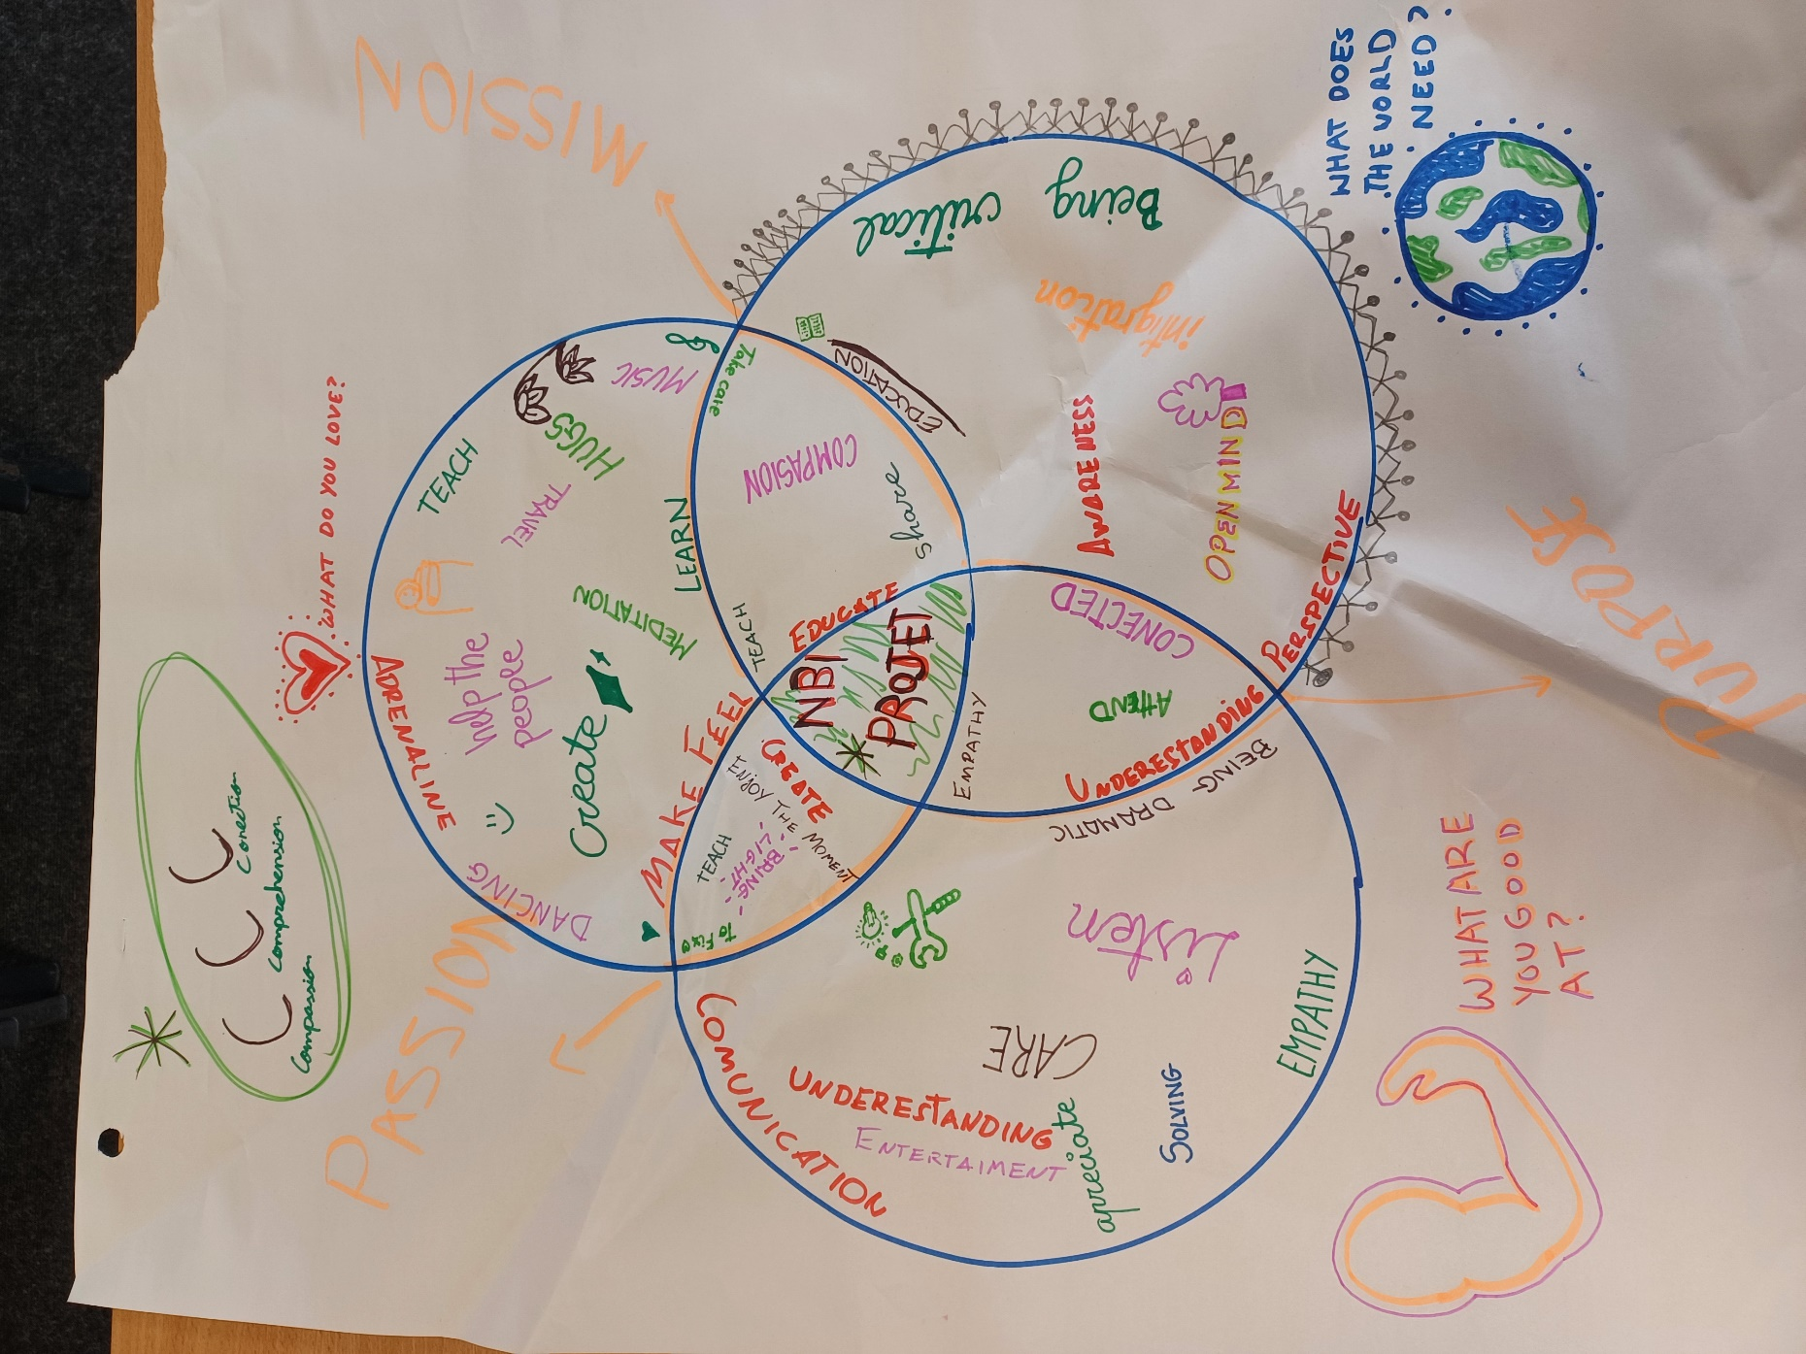
What participants think a Nature Based Initiative should consist of……

- Further Reading
- Youth Empowerment in Ireland – An overview of young people’s political participation and access to rights, National Youth Council of Ireland, 2015
- European Youth Portal, https://youth.europa.eu/strategy/empower_en

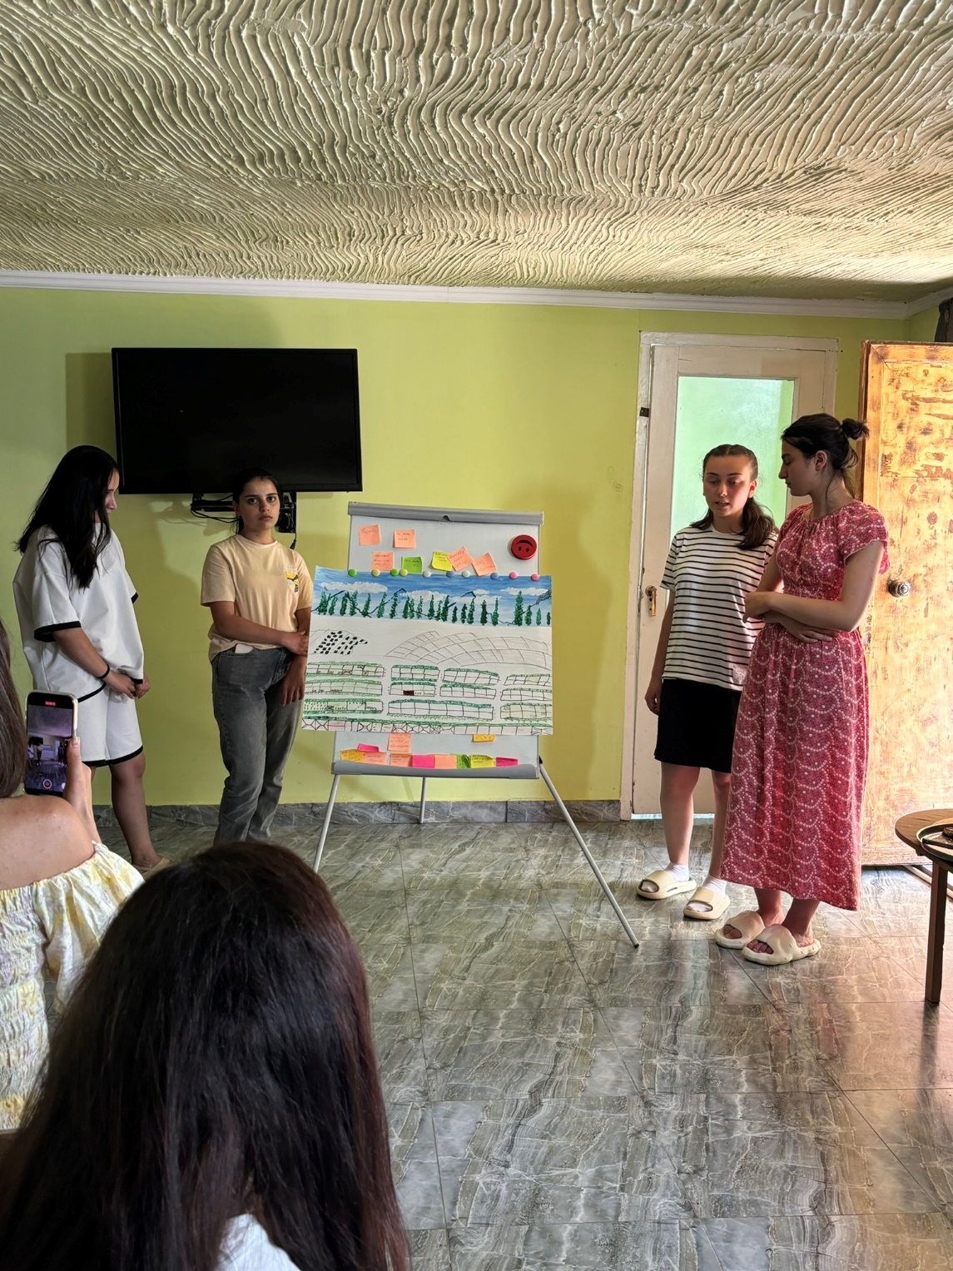
Young people in Armenia presenting their Nature Based Initiative during Dragon’s Den

- PROJECT MANAGEMENT
- Aim of the Session
The aim of this session is to give young people the ‘tools’ and the confidence to deliver on their ideas and imagination, to develop confidence and agency, and to empower participants through learning new skills and knowledge

- Key Messages
- Project management is the application of processes, methods, skills, knowledge and experience to achieve specific goals. It has final deliverables that are constrained by time and budgets.
- When we apply that definition to Youth Work, it’s obvious that it needs to be simplified, so what we are trying to do in this session is to boost confidence through planning and preparing, developing implementation plans, and making sure that the Team knows what it has to do.
- It’s vitally important that young people buy co-design the plans, so that they feel a sense of ownership and motivation
- It’s also important that the plans are achievable – we do not set young people up to fail. So the plans must be realistic and feasible, as well as specific, timed and measurable.

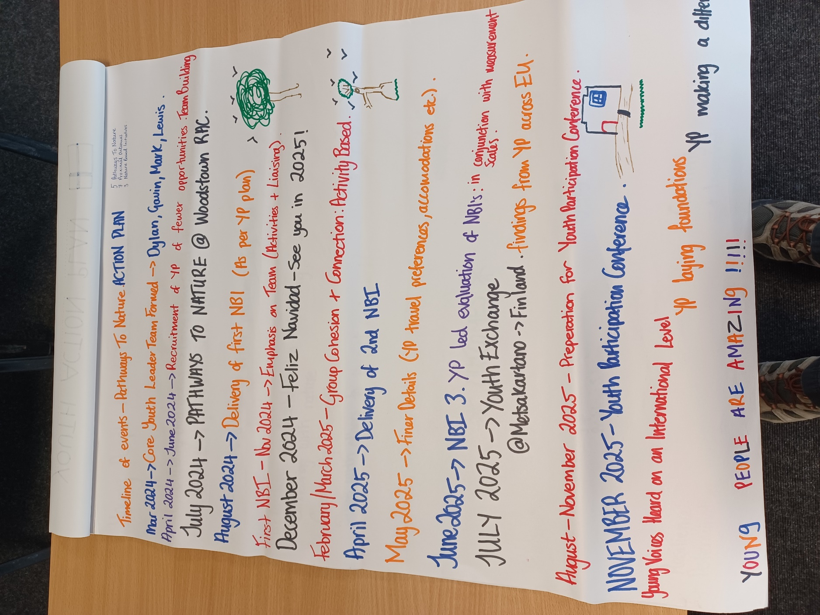
A Youth-led Timeline for planning to deliver Nature Based Initiatives over a year

- Sample Exercises
The 5 W’s and H:
The term ‘5W’s and H’ refers to the 6 basic questions to ask when attempting to gather information or address challenges. The questions are –
Who?
What?
Where?
When?
Why?
How?
The goal in using these questions as a framework is to seek factual answers so that the group has clarity about what they are trying to achieve. The Youth Worker can use any type of creative methodologies (drawing, pottery, theater) to elicit answers but once clarity is gained, the process of planning is underway

- Useful Further Reading
- https://www.youth.ie/wp-content/uploads/2021/03/Guide-to-Project-Planning-Framework.pdf
- https://www.salto-youth.net/tools/toy/reference/project-management-for-beginners-in-youth-work.4626/

